CSA5103-Cryptography And Network Security
Experiment 11

Program :
import math
# Total possible Playfair keys
total_keys = math.factorial(25)
# Approximate power of 2
total_power = math.log2(total_keys)
# Equivalent keys due to row and column rotations
equivalent_keys = 5 * 5
# Effectively unique keys
unique_keys = total_keys // equivalent_keys
# Approximate power of 2
unique_power = math.log2(unique_keys)
print("PLAYFAIR CIPHER KEY SPACE")
print("--------------------------")
print("Total possible keys = 25!")
print("Total possible keys =", total_keys)
print("Approximately = 2^%.2f" % total_power)
print("\nEquivalent keys per encryption = 25")
print("\nEffectively unique keys = 25! / 25")
print("Effectively unique keys =", unique_keys)
print("Approximately = 2^%.2f" % unique_power)

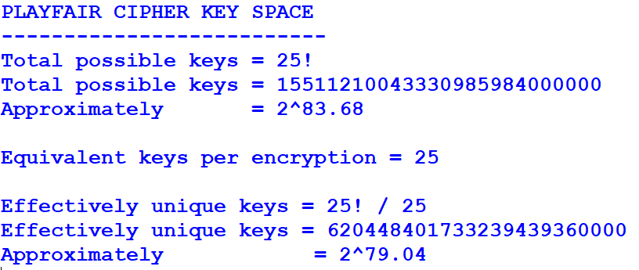
Output:

